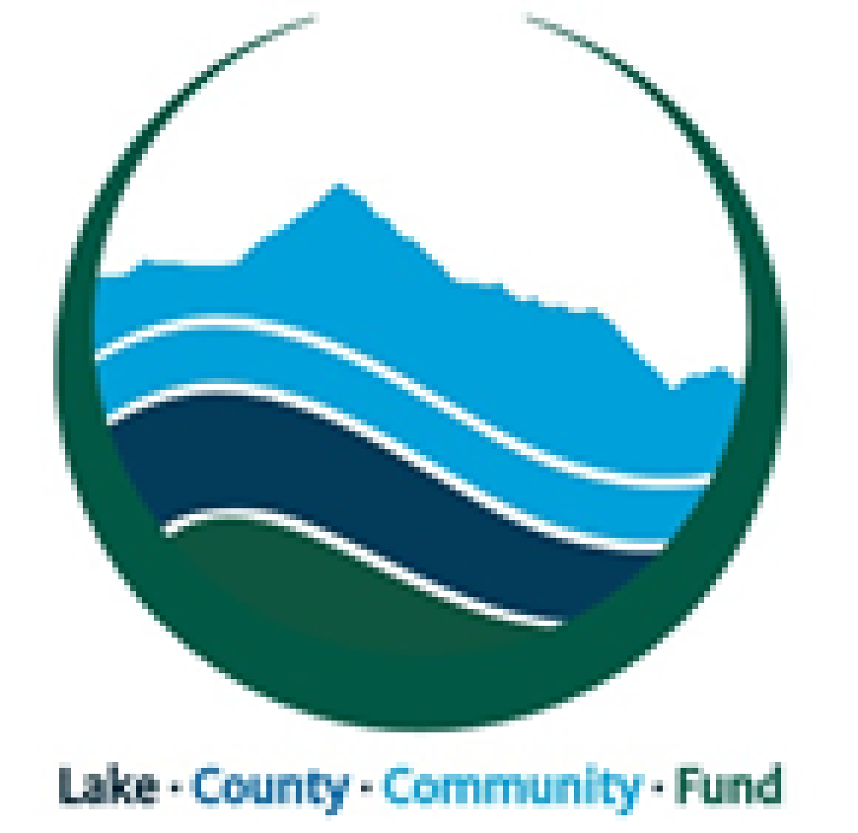
LAKE COUNTY COMMUNITY FUND

Community Grant Guidelines & Application

COMMUNITY GRANT-MAKING GUIDELINES:

We envision a Lake County that has an abundance of sustainable philanthropic resources to support a thriving community. To arrive at that vision, the Lake County Community Fund (LCCF) provides a means to expand the capacity of local organizations, promote and facilitate giving opportunities, and inspire investment in Lake County.

Grant making at the LCCF is a competitive and thoughtful process. We undertake a careful assessment of community needs, research existing programs, and identify gaps in services in order to make grants that will provide the most effective support for the Lake County community. We want LCCF grants to provide support for Leadville/Lake County nonprofits’ greatest needs. We also hope that LCCF grants will highlight community buy-in for valuable local endeavors, including efforts that may be in the launch phase and working to get off the ground. The LCCF focuses on funding projects that fit within the following areas:

- Arts and Culture
- Community and Economic Development
- Education and Training
- Environmental Initiatives
- Health and Wellness

The LCCF awards grants to local nonprofit organizations and partnerships that meet our mission statement objectives and other selection criteria; programs that increase the capabilities and capacity of other local nonprofit organizations; and infrastructure projects focused on developing a sustainable economy or programs aimed at improving the quality of life for people in the community. Currently, we do not offer grants to individuals or multi-year funding.

The Board of Directors of the LCCF determines final approval of all grants awarded and may not be able to fund all qualifying requests. However, all requests which meet the funding guidelines of the LCCF will be given full consideration by the Board. The LCCF does not discriminate based on race, religion, sexual preference, physical circumstances or national origin. Applicants must hold similar standards. Grant applications from organizations known to have discriminatory policies will not be considered.

GRANT-MAKING PROCESS:

The LCCF offers at least one grant-making cycle each year. Notice of grant opportunities may be provided through local newspapers and social media. Applications are generally available at least four weeks prior to the grant deadline and can be located on the LCCF website under “Grants.” You can also check the website for our eligibility criteria to ensure your organization’s funding request fits with our mission and funding areas, or contact the LCCF at director@lakecountycommunityfund.org with any questions prior to submitting a proposal. Grant applications are not automatically mailed to organizations that are past funding recipients. It is the responsibility of the organization to request the current grant application documents. Late and/or incomplete applications will not be accepted or considered for funding support.

The amount of funding available will be announced prior to the opening of each grant cycle and will vary from year to year. The LCCF will strive to direct grants to programs, projects and entities that most clearly address key community needs. There may be years in which the LCCF prioritizes one funding area, or a narrower focus within a funding area, to maximize our impact with the grant funds available. This will always be determined by the community’s needs.

GRANT FUNDS AVAILABLE:

For its 2018 grant cycle, the LCCF will make $20,000 available for grant awards. Applicants can apply for up to $10,000 in grant funding. To learn about past LCCF grant awards, the press release announcing our 2017 grantees and grant awards can be found on the LCCF website under “Grants.”

GRANT-MAKING TIMELINE:

Please note the following dates for the 2018 LCCF Community Grants:

March 15 | LCCF Community Grant application available on the LCCF website
April 5 | Information session for potential grant applicants (12-1pm) *Not mandatory*
April 16 | “Intent to Apply” emailed to director@lakecountycommunityfund.org by midnight  - Email should include 1) A 1-2 sentence overview of your intended funding request, 2) the LCCF priority area you feel your proposal addresses, and 3) an estimate of the amount you plan to request.
May 1 | Grant applications due to director@lakecountycommunityfund.org by midnight
Mid-May | LCCF Board of Directors review proposals
June 1 | Grant awards announced

WHO CAN APPLY:

Entities with a project that meets the goals of the Lake County Community Fund may apply. Proposed projects must benefit the Lake County community.

ELIGIBILITY CHECKLIST:

Proposals must fulfill the following requirements to be considered by the LCCF:
- Eligible applicants include nonprofit 501(c)3 agencies, schools, governments or collaboratives that have a nonprofit or government agency as a fiscal agent.
- Organizations applying for funds must be based in Lake County or partnered with a Lake County agency.
- Organizations applying for funds must be a charitable organization as designated by the IRS or partnered with a charitable organization as a fiscal agent.
- Any proceeds generated as a result of grant funds received must be used for charitable purposes.
- Proposed projects must be for the benefit of the Lake County community.
- Proposals must comply with all Federal, State, and local laws.
- Proposals must have a measurable outcome that can be evaluated.
- Proposals should demonstrate community support either through matching funding or in-kind services.
The following types of requests are ineligible:
- Requests for support related to any political campaign, issue or candidate.
- Already completed programs or projects.
- Sponsorship, underwriting or membership requests.

HOW TO APPLY:

All requests for funding must be submitted by the appropriate deadline and include:
- Proposal Summary Form
- Project Narrative
- Project Budget
- Project Work Plan
- Proof of 501(c)3 or equivalent status

PROPOSAL REVIEW PROCESS:

Submitted proposals will be reviewed by the LCCF Executive Director to ensure they are complete. Applicants will be contacted about incomplete proposals and back-up documentation. Complete proposals will be reviewed and scored by the LCCF Board of Directors based on the criteria listed above. Applicants will be notified of their funding status no later than one week following the Board of Directors’ review meeting.

REQUIREMENTS FOR GRANT RECIPIENTS:

Applicants awarded funding must comply with certain requirements, which may include:
- Sign and return a grant acceptance letter within two weeks of award notification.
- Submit a project completion report within one year of receiving funds.
- Submit financial documentation demonstrating how funds were spent.
- Acknowledge the Lake County Community Fund in the project’s promotional materials.
- Contact the Lake County Community Fund for advance approval of spending changes that total more than 25% of the grant award.

QUESTIONS?

For more information, please email director@lakecountycommunityfund.org or visit the Lake County Community Fund website: www.lakecountycommunityfund.org

Lake County Community Fund – Community Grant Application
A. PROPOSAL SUMMARY FORM
Organization Requesting Funds

Name of Primary Contact Person

Contact Information | Phone:
 | Email/ Website:
 | Address:
 | City: | State: | Zip:
Other Organizations Collaborating on this Project

Check the Funding Area for which you are Seeking Funds | ☐ Arts & Culture ☐ Education & Training  ☐ Health & Wellness ☐ Community & Economic Development  ☐ Environmental Initiatives
Summary of Project
(3-4 Sentences)

Total Amount Requested | $

☐ I agree that the information contained in this application is true and correct to the best of my knowledge.

Signature: Date:

Lake County Community Fund Use ONLY
Application Received By: Date Received:
B. PROJECT NARRATIVE
Please describe your proposed project in 2 pages or less by responding to each of the following questions:
- Overview. What will you do and how will you do it?
- Need. (Please briefly respond to both parts A and B.) A. Community Need. Describe how your proposed project will address critical community needs or advance community goals related to one of our five funding areas (Arts and Culture, Community and Economic Development, Education and Training, Environmental Initiatives, Health and Wellness). B. Organizational Need. In the past, many applicants were awarded partial funding in response to their LCCF Grant Proposals. Please speak to the greatest need that exists at your organization with regard to this proposal and help us understand how your organization would handle a partial funding award.
- Impact. Describe the impact your project will have on the Lake County community.
- Efficiency. Describe how your project leverages existing resources (through partnerships, collaborations, volunteer support, etc.) to ensure that grant funds are used as efficiently as possible.
- Inclusiveness. Describe steps your organization is taking to advance diversity, equity and inclusion in its programs, staff, board, and volunteers.
- Engagement. How is the Lake County community engaged in this project?
- Evaluation. How do you plan to measure the success of this project?
- Sustainability. Please share at least one creative strategy for sustaining this project.
C. PROJECT WORK PLAN
Please complete our project work plan template with a detailed work plan for your proposed project. The work plan should include a timeline demonstrating when project tasks will be completed and note individuals and entities responsible for completing the work.
D. PROJECT BUDGET
Please complete our project budget template with a detailed budget for your proposed project. A sample budget is provided in Tab 1 for your guidance. Please complete and submit the budget template in Tab 2. Proposals should demonstrate community support by quantifying matching contributions or in-kind services as part of the project budget.
E. ATTACHMENTS
Please ensure that the following items are included with your completed proposal:
☐ Copy of your organization’s 501(c)3 status letter from the IRS or related certification
☐ Completed Proposal Summary Form
☐ Project Narrative (2 pages or less)
☐ Detailed Project Work Plan
☐ Completed Project Budget
F. PROPOSAL SUBMISSION
Please email your completed proposal and required attachments electronically to director@lakecountycommunityfund.org by midnight on May 1, 2018.

